CWRU and Cleveland VA’s groundbreaking $1.14M project: Using AI to fight colorectal cancer
- Updated: Oct. 15, 2024, 1:41 p.m.
- |Published: Oct. 15, 2024, 1:30 p.m.
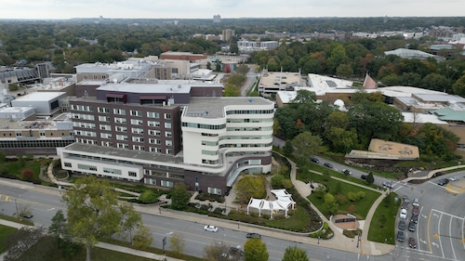
With a new four-year, $1.14 million grant from the U.S. Department of Veterans Affairs, researchers at Case Western Reserve University and the Louis Stokes Cleveland VA Medical Center, seen here, will use AI to determine personalized treatment for veterans with rectal cancer. John Pana, cleveland.com
By
- Julie Washington, cleveland.com
CLEVELAND, Ohio — Researchers at Case Western Reserve University and the Louis Stokes Cleveland VA Medical Center will investigate how artificial intelligence can be used to treat colorectal cancer, thanks to a new four-year, $1.14 million grant from the U.S. Department of Veterans Affairs.
CWRU and the Cleveland VA recently made the announcement in a joint news release.
0:15
/
0:45
Skip Ad
Artificial intelligence will allow researchers to develop an algorithm that analyzes MRI scans to better understand how rectal tumors respond to treatment, according to Satish Viswanath, co-director of the Center for AI Enabling Discovery in Disease Biology at CWRU and a biomedical engineer at the Cleveland VA.
“Time is of the essence, especially for veterans who tend to be older than other rectal cancer patients,” Viswanath said. “Our project addresses this critical need to improve outcomes and quality of life for veterans.”
Other VA co-investigators are also working on the research project, the news release said.
Colorectal cancers are the third-most common type of cancer among military personnel, affecting up to 8% of veterans and 5% of active-duty service members, according to the American Cancer Society.
More than 152,000 patients in the United States will be diagnosed with colorectal cancer in 2024, with more than 46,000 localized to the rectum, according to the cancer society.
The artificial intelligence tool, called the computational image rectal response classifier, will assess MRI data in more detail than human evaluation alone.
The hope is that the artificial intelligence tool will allow doctors to offer veterans treatment customized for each patient, or determine whether a patient may be resistant to a specific treatment regimen, the joint statement said.
“Rectal cancer patients undergo a one-size-fits-all treatment protocol that almost always requires surgery, but surgery comes with inherent risks and complications, including patients having a worse quality of life,” said Eric Marderstein, co-investigator and section chief of general and colorectal surgery at the Cleveland VA Medical Center. “We urgently need better markers to assess the risk of metastasis and invasion so patients can be recommended additional therapy to maximize their chance of survival.”
Julie Washington covers healthcare for cleveland.com. Read previous stories at this link.

